- launch the aws_ec2 instance with all security traffic release
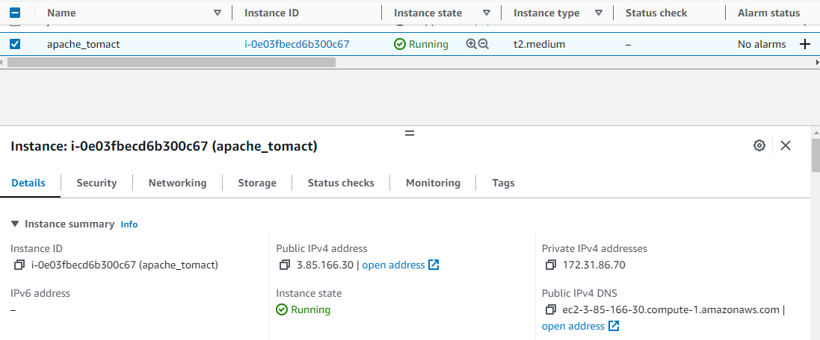

- run the ssh connection 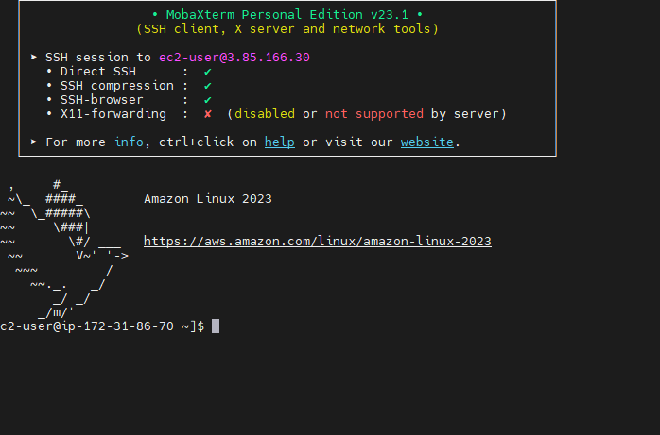

- Change host name apache_tomcat
Sudo hostnamectl set-hostname tomcat
- Change to root user
Sudo su -
- install java 1.8 version
Yum install java-1.8* -y
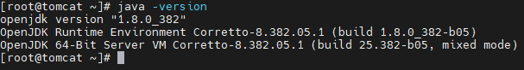

- Check wget package are installed or not
- Go to tomcat official website and select tomcat.trz file with copy link
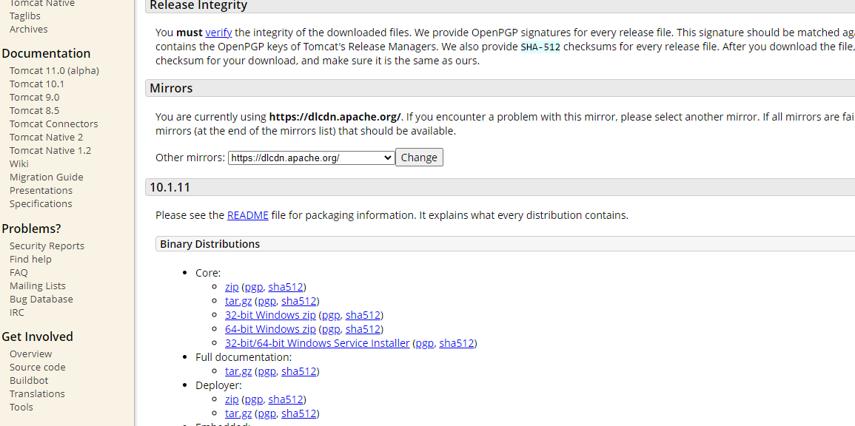

https://dlcdn.apache.org/tomcat/tomcat-10/v10.1.11/bin/apache-tomcat-10.1.11.tar.gz

- copy url with wget command
Wget https://dlcdn.apache.org/tomcat/tomcat-10/v10.1.11/bin/apache-tomcat-10.1.11.tar.gz

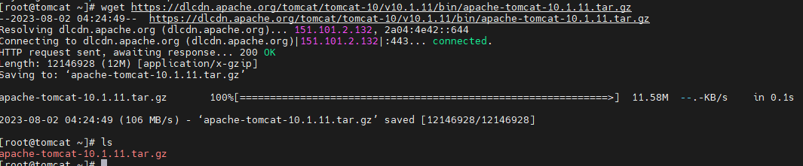

- Tar file move to /etc dir
mv apache-tomcat-10.1.11.tar.gz /etc
- Change dir to /ect
Cd /etc
- unzip tar file
Tar -xvf apache-tomcat-10.1.11.tar.gz
- Start the tomact application
Cd /apache-tomcat-10.1.11

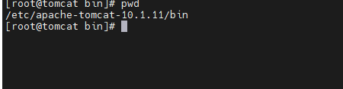

- start the .sh file
./startup.sh or sh startup.sh
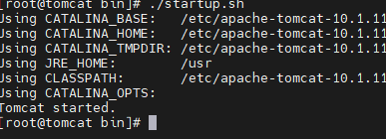

- check browser with public ip and portnumber
0.0.0.0:8080
- tomacat default portnumber 8080

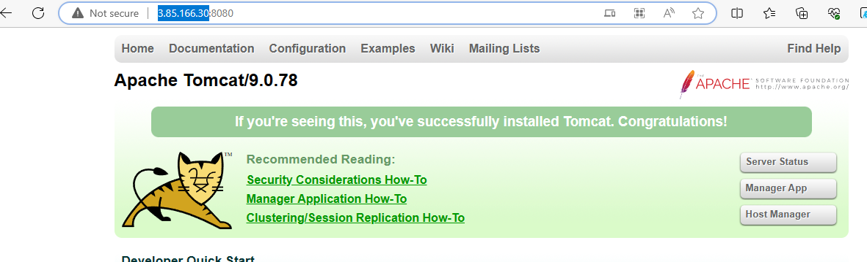

- Now install webserver
Yum install httpd -y
- Httpd service start
Systemctl start httpd
- Check public ip address with port number 80
0.0.0.0:80
- Connection between to servers tomcat and webserver
setsebool -P httpd_can_network_connect on
- Chabge dir to httpd package, and chabge dir conf.d
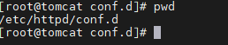

- Wriate a proxy role

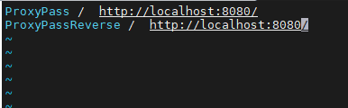

- service start and start
Systemctl stop httpd
Systemctl start httpd

- now check browser with port number 80
0.0.0.0:80
